Phase of Learning | Phonemes/Graphemes taught | High Frequency/Tricky Words: Reading | High Frequency/Tricky Words: Writing
Phase 1 | Environmental sounds, instrumental sounds, body percussion, rhythm and rhyme, alliteration, voice sounds, oral blending and segmenting.
Phase 2 | Set 1: s, a, t, p  Set 2: i, n, m, d  Set 3: g, o, c, k  Set 4: ck, e, u, r  Set 5: h, b, f, ff, l, ll, ss  Taught grapheme phoneme correspondence for above phonemes.  Read words with taught phonemes.  Read short captions.  Write CVC words with taught sounds. | C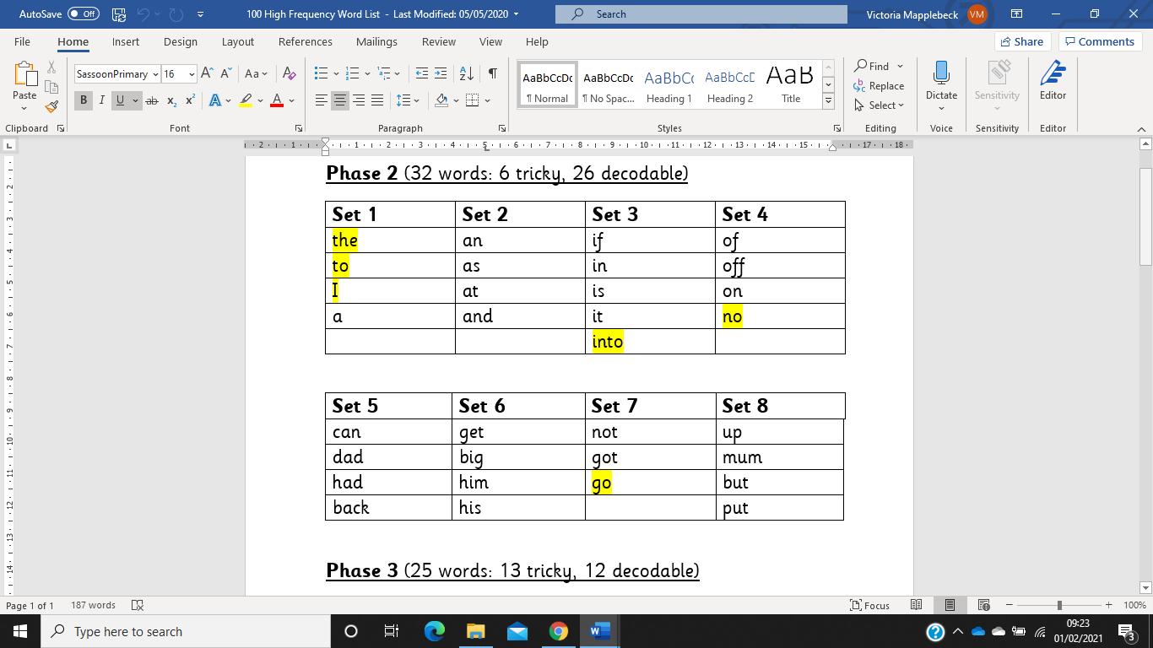 | and  to  the
Phase 3 | Set 6: j, v, w, x  Set 7: y, z, zz, qu  Consonant digraphs: ch, sh, th, ng  Vowel digraphs/trigraphs: ai, ee, igh, oa, oo, ar, or, ur, ow, oi, ear, air, ure, er  Taught grapheme phoneme correspondence for above phonemes.  Read words and sentences containing taught phonemes and all tricky words taught.  Write simple captions/sentences using taught phonemes and tricky words for writing.  Learn the alphabet song to learn letter names. | 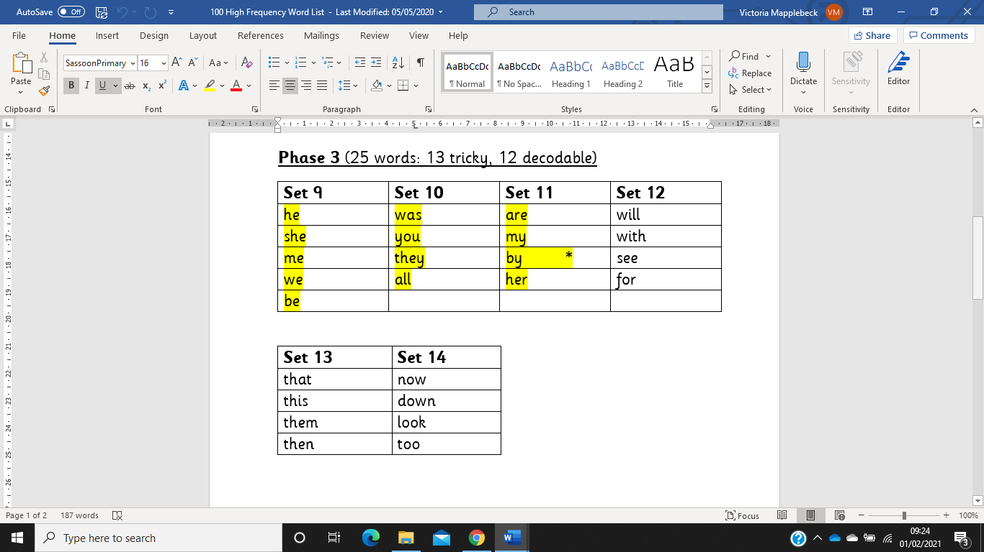 | no  go
Phase 4 | Children learn to read and spell words with adjacent consonants, such as:  bl, br, ch, ck, cl, cr, dr, fl, fr, gh, gl, gr, ng, ph, pl, pr, sn, sp, st, sw, sk, sl, sm, nch, str, shr, scr  Children also learn to read polysyllabic words.  Continue to learn the alphabet song and letter names.  Read words and sentences containing taught phonemes, adjacent consonants, and all tricky words taught.  Write words and sentences containing taught phonemes, adjacent consonants, and phase 2 and 3 tricky words. | 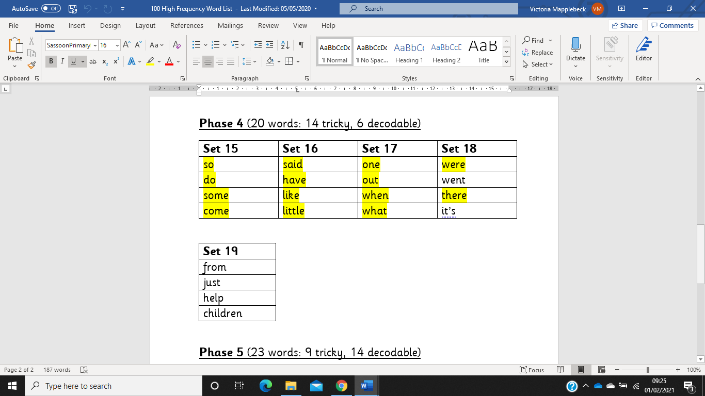 | he  you  they  all  are  my  her  she  me  we  be  was
Phase 5 | Learning alternative graphemes e.g. they already know /ai/ as in rain, but now they will be introduced to /ay/ as in day and /a-e/ as in make.  The following alternative graphemes will be taught: wh, ph, ay, ou, ie, ea, oy, ir, ue, aw, ow, ew, oe, au, ey, a-e, e-e, i-e, o-e, u-e.  Alternative pronunciations for graphemes will also be introduced, e.g. /ea/ in tea, head and break.  Alternative spellings of known phonemes, e.g. the /igh/ phoneme learnt during phase 3, can be spelt as /ie/ in pie, /y/ in by and /i-e/ in time. | 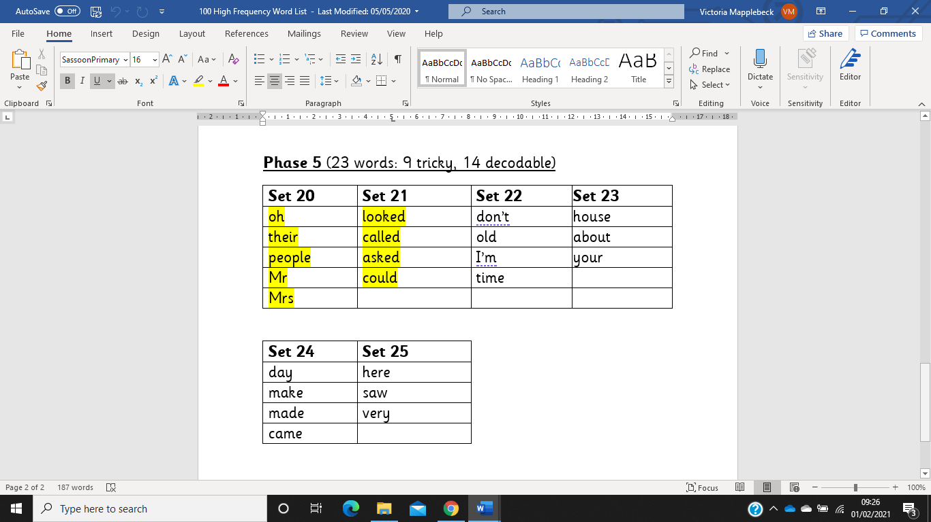 | said  when  what  out  oh  their  people  Mr  Mrs  looked  called  asked  so  have  like  some  come  were  there  little  one  do
Phase 6 | Consolidation of Phase 5 learning, particularly alternative pronunciations, and spellings of graphemes. | Consolidation of the 100 High Frequency words.  Learn to read the Next 200 Common Words. | Consolidation of all of the above words.  Spelling of Year 1 and 2 Common Exception words.  Spelling of words with suffixes, both with and without changes needing to be made to the base word. Example suffixes are:  -s, -es, -ing, -ed, -er, -est, -y, -en, -ful, -ly, -ment, -ness.

Below is an outline of when each of the above phases will be taught. However, in each cohort there will be differing needs and therefore children who are working above or below what is outlined here.
Nursery:
Phase 1 – throughout the year
Phase 2 – throughout the year. Exposure to one new phoneme and grapheme per week
Reception:
Phase 1 – throughout the year
Phase 2 – Autumn 1 and 2
Phase 3 - Autumn 2, Spring 1, Spring 2, Summer 1
Phase 4 – Summer 2
Year 1:
Phase 3 – revision during Autumn 1 and 2
Phase 4 – revision during Autumn 1 and 2
Phase 5 – starting in Autumn 2 and continuing throughout the rest of the year
Year 2:
Phase 5 – revision throughout the year
Phase 6 – all year
Year 3:
Consolidation of all learning in Phases 3-6.

