

**Planning Mathematics**

At Morley Victoria we use the White Rose Maths Schemes of Learning. These detailed documents ensure that each teacher has an in-depth basis for the progression of skills and knowledge to inform and create their own, bespoke, long-term plan for their respective year group. For knowledge to be secure in the long-term memory, it is essential that topics are revisited, and links are made with these between topics. We have planned retrieval practice daily and allow teachers to pre teach areas, consolidate already taught areas and close any keys gaps in the children’s learning. Securing key number facts such as times tables, number bonds and mental addition and subtraction skills are also key in becoming a fluent mathematician. Becoming secure in these key areas allows children to learn and apply these skills to new areas of learning as their short-term memory can be used solely in their new area of mathematical learning. Teacher’s plan these objectives and the progression in these very carefully and this is represented in their planning across the year.

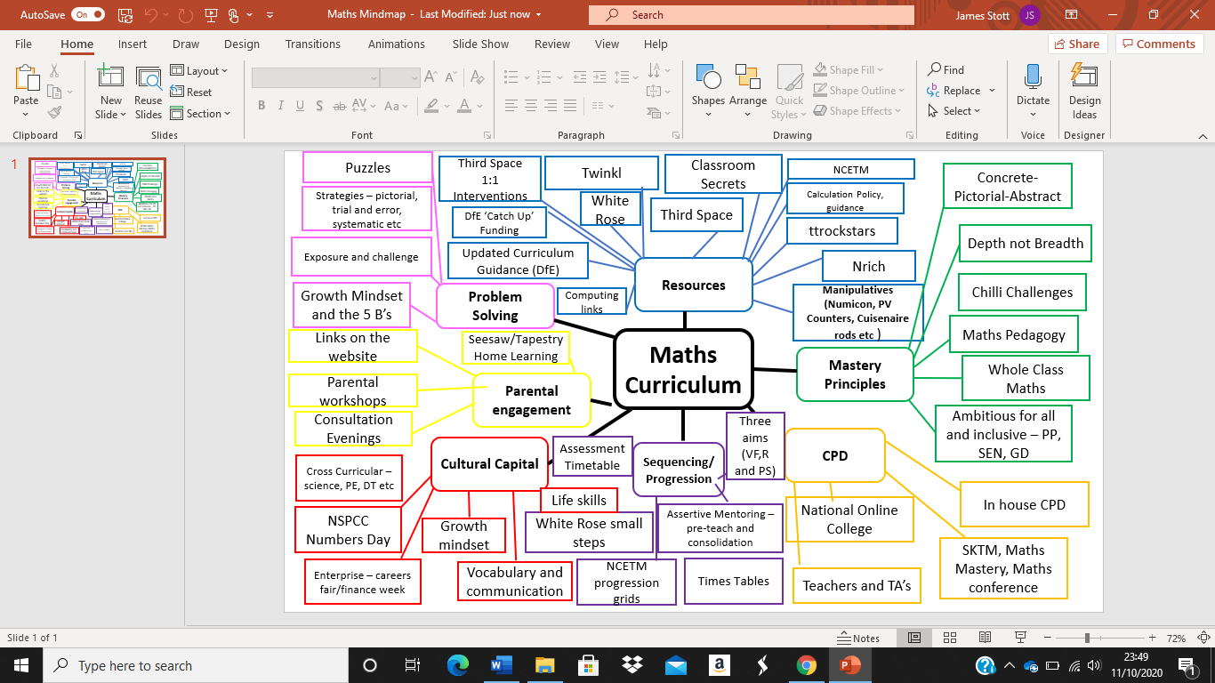The plans are a flexible, working document which allow teachers to spend more time on key objectives, for example place value, if they feel that this is required. Our long-term plans also consider the 8 key principles outlined in the document ‘Improving Mathematics in Key Stage 2’ and also the 5 key recommendations in the ‘Improving Mathematics in Early Years and Key Stage 1’, released by the Education Endowment Foundation (EEF).

**Morley Victoria**

**Mathematics**

**Curriculum**

Please see below the following links for the key schemes, websites and documents used within our school for teaching and learning in mathematics:

**White Rose Maths Schemes of Learning:**

[**https://whiterosemaths.com/resources/primary-resources/primary-sols/**](https://whiterosemaths.com/resources/primary-resources/primary-sols/)

**NCETM Progression Grids:**

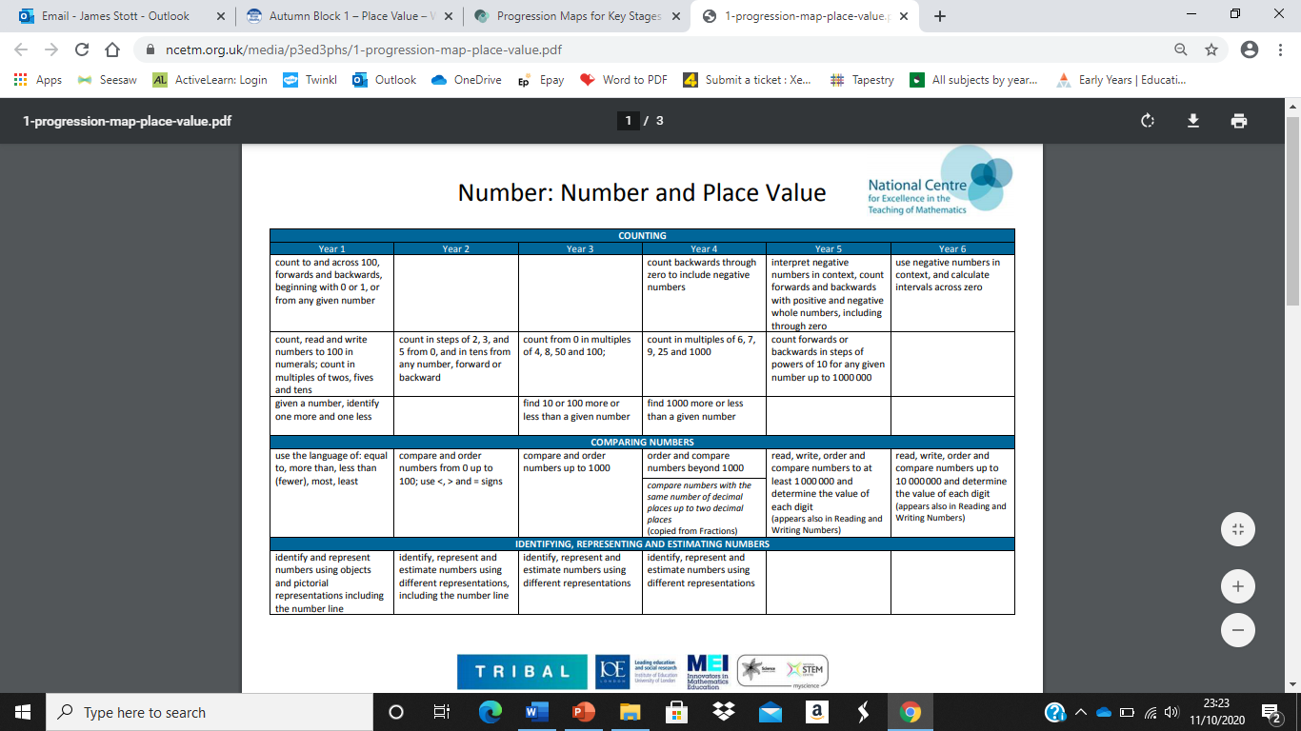[**https://www.ncetm.org.uk/classroom-resources/progression-maps-for-key-stages-1-and-2/**](https://www.ncetm.org.uk/classroom-resources/progression-maps-for-key-stages-1-and-2/)

**Education Endowment Foundation (EEF):**

**Improving Mathematics in Key Stage 2 (&3)**

[**https://educationendowmentfoundation.org.uk/public/files/Publications/Maths/KS2_KS3_Maths_Guidance_2017.pdf**](https://educationendowmentfoundation.org.uk/public/files/Publications/Maths/KS2_KS3_Maths_Guidance_2017.pdf)

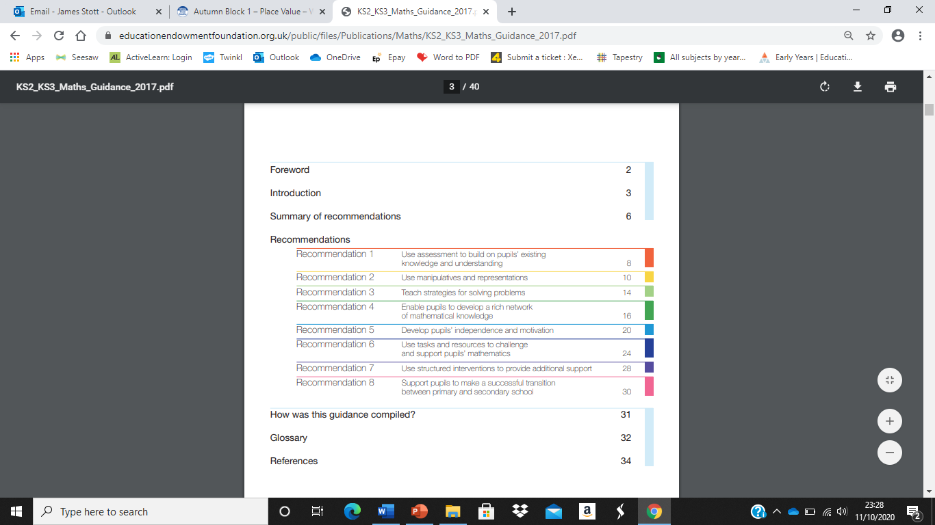

**Education Endowment Foundation (EEF):**

**Improving Mathematics in EYFS and Key Stage 1**

[**https://educationendowmentfoundation.org.uk/public/files/Publications/Maths/EEF_Maths_EY_KS1_Guidance_Report.pdf**](https://educationendowmentfoundation.org.uk/public/files/Publications/Maths/EEF_Maths_EY_KS1_Guidance_Report.pdf)

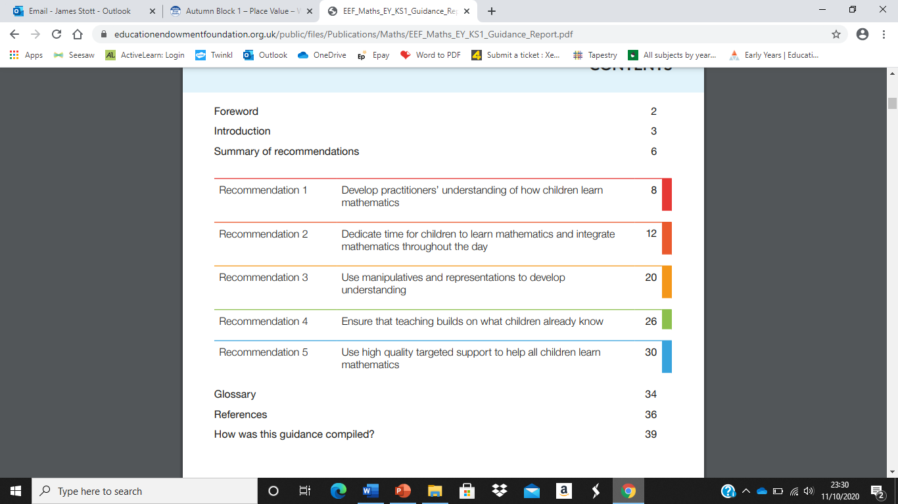

**Example of Assertive Mentoring (‘Big Maths’)**

Example of retrieval practice:

