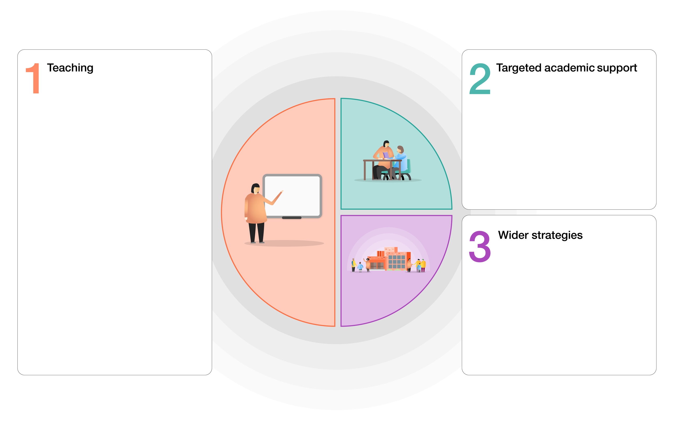

|  |  |  |  |
| --- | --- | --- | --- |
|  | Reading | Writing | Maths |
| EYFS/KS1 |  |  |  |
| Current |  |  |  |
| Barriers | EAL | SEN | OTHER |

**Childs name: A Pupil Class: 5AA**

**What support does the child have for emotional and social, attendance, behaviour etc**

* Work with inclusion team on self-regulation – small group
* Member of the rethink food team
* Paid for place in Rocksteady
* Reading Ambassador

**Anything over and above wave 1 teaching.**

* 1 to 1 tutoring on maths with school tutor
* Times Table club on a Thursday Lunchtime
* Individual Reader x 2 weekly

**Look at the Strategy Statement, SDP and Teaching and Learning Toolkit**

<https://educationendowmentfoundation.org.uk/education-evidence/teaching-learning-toolkit>

**What other strategies do you employ in addition to the whole school strategies?**

* Collaborative learning in class
* Small group in maths
* Teaching assistant intervention (pre teach and editing in writing)

**PUPIL PREMIUM TIERED MODEL**